WEEK 1: LEARNINGS

NEURAL NETWORKS:

A neural Network is designed to find/recognize patterns and solve patterns related to it

It consists of layers of interconnected nodes that process and transmit information

There are mainly 3 layers in a Neural networks

1. INPUT LAYER: Where a specific inputs/images are given to the model for predictions
2. HIDDEN LAYERS: These hidden layers can be consisting of any sub-layers; this is where the entire prediction and associated problems are solved.
3. OUTPUT LAYER: This is the layer through which the entire output is produced by the model is displayed.

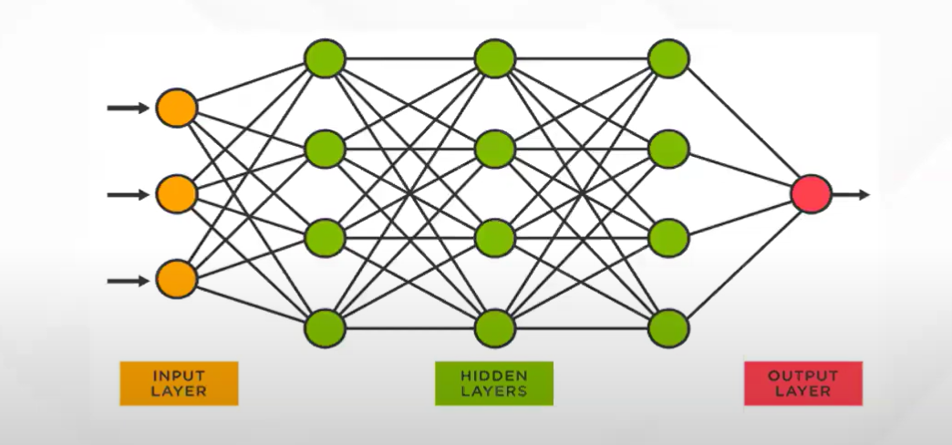

COMPONENTS OF NEURAL NETWORKS:

1. INPUTS: Every model are given inputs in the form of text or Image or videos.
2. WEIGHTS: They are the coefficients used by the model while predicting an outcome for the input given to the user. These weights are the integral part of the model for adjusting the accuracy.
3. BIAS: It is some predefined conditions or weights given to the model so that the errors of the model can be reduced and produce an effective output
4. ACTIVATION FUNCTION: The binding functions which uses the weighted sum of the inputs and weights into a mathematical expression to make predictions

There are many forms of Activation Function which have their own use cases.

SHALLOW AND DEEP NEURAL NETWORKS:

Shallow Neural Networks are the ones which have very low hidden layers in between the input and output layers.

Deep Neural Networks have various hidden layers between the input and output layers.

* For Binary Classifications (Low level or Simpler Classification) Sigmoid Activation function is used
* For Multi Class Classifications Soft-max Activation function is used

All the models generally created are called as Artificial Neural Networks and the they work on tabular data.

OVERFITTING:

When a model can’t fit well on the unseen dataset. It can be observed /recognized if the error on the testing dataset is much greater than the training dataset.

To reduce the overfitting the developer, need to reduce the complexity of the model by removing some additional hidden layers or some extra neurons.

UNDERFITTING:

When the model is unable to model / recognize the training dataset along with the testing dataset it is said to be underfitting. These models are not suitable and they have very low performance.

To change a model status from underfitting to best fitting the developer needs to add more neurons to the hidden layers.

MACHINE LEARNING:

The machine learning algorithms are the one used to just classify the data when the inputs are given. The features of an image should be extracted from the image before classification so that they can be utilized using an additional feature extraction of the input.

DEEP LEARNING:

In deep learning models when the input is given fed to the model the classification output of the model will be provided and also the features will be extracted from the input in the same hidden layers. The accuracy of the predictions increases with increase in the training set.

TYPES OF NEURAL NETWORKS:

1.Artificial Neural Networks: This model works on fully structured data that is using tabular data.

2.Convolutional Neural Networks: This model is used to handle the image datasets.

3.Recurrent Neural Networks and Long Short-Term Memory: This model is used to handle the text inputs by the user.

The Convolutional Neural Networks, Recurrent Neural Networks and the Long Short-Term Memory belongs to the Deep learning networks.

The Artificial Neural Networks don’t give good accuracy to the respective datasets

CONVOLUTION LAYER:

When the user image is fed to the model each pixel with data is converted into a matrix represented with 1 when data is present and 0 otherwise Then these matrices is combined with a filter (a general matrix given with certain weights). Each combination obtained is then stored in another matrix which is used for processing called as Feature.

These are some of the steps involved in feature extraction.

The features are of smaller size than the Actual image matrix. The matrix can be resized by adding required amount of Padding to the main matrix.

The size oTf feature matrix is found using the formula

Here W is original size

F is the filter size

S is the stride

P is the padding

ReLU Activation:

The ReLU Activation is used to remove all the negative values present in the feature matrix and replace it with 0s.

Output is f(x) = max (0, x)

Pooling Layer:

In this process the entire feature matrix is further more compressed by selecting only the max features of the submatrix of order n-2

Flattening:

Here in this process the final matrix obtained is changed into a linear array so that it can be used as a series of inputs to the Model to which necessary weights are added to identify and classify the model.